Affix patient label here
Distress Thermometer and Checklist
Distress is often unpleasant feelings or emotions that can impact on the way you think, feel and act. It can include feelings like sadness, worry, anger, helplessness and guilt. It’s common for someone who has been diagnosed with cancer to experience some level of distress at some point in time (anywhere from diagnosis and beyond). Your level of distress may only be minor or could be more serious where you find that you’re not able to do the things you used to do. It’s important for your Treatment/Medical Team to know how you’re feeling. By completing the following tool your team will work with you and help link you with other supportive services (for example counsellors, social workers, dietitians) when you need or want to.
Instructions:  - please circle the number 0 – 10 that best describes how much distress you have been experiencing in the past week including today | - please indicate if any of the following has been a problem for you in the past week including today. Be sure to check YES or NO for each
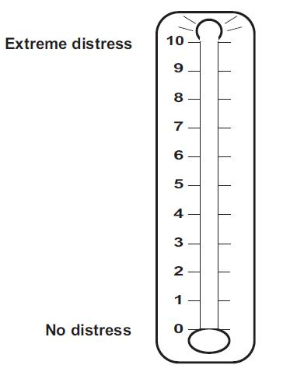 | YES | NO | Practical Problems | YES | NO | Physical Problems
 |  |  | Child care |  |  | Appearance
 |  |  | Housing |  |  | Bathing / dressing
 |  |  | Insurance / financial |  |  | Breathing
 |  |  | Transportation |  |  | Changes in urination
 |  |  | Work / school |  |  | Constipation
 |  |  | Treatment decisions |  |  | Diarrhoea
 |  |  |  |  |  | Eating
 |  |  | Family Problems |  |  | Fatigue
 |  |  | Dealing with children |  |  | Feeling swollen
 |  |  | Dealing with partner |  |  | Fevers
 |  |  | Ability to have children |  |  | Getting around
 |  |  | Family health issues |  |  | Indigestion
 |  |  |  |  |  | Memory / concentration
 |  |  | Emotional Problems |  |  | Mouth sores
 |  |  | Depression |  |  | Nausea
 |  |  | Fears |  |  | Nose dry / congested
 |  |  | Nervousness |  |  | Pain
 |  |  | Sadness |  |  | Sexual
 |  |  | Worry |  |  | Skin dry / itchy
 |  |  | Loss of interest in usual activities |  |  | Sleep
 |  |  |  |  |  | Substance abuse
 |  |  | Spiritual / religious / cultural concerns |  |  | Tingling in hands and feet
Other Problems: _________________________________________________________

________________________________________________________________________

