Mild Traumatic Brain Injury (TBI)
Mild traumatic brain injury (TBI) including concussion can occur from a bump, blow or jolt to the head or body that shakes the brain inside the skull, possibly causing an injury to brain tissue. Mild TBI can occur without loss of consciousness, and changes may not show on a brain scan.

The ability of brain cells to relay information may be affected causing a variety of symptoms. You may become more aware of symptoms as you return to more demanding tasks. It is normal to experience some symptoms after a mild TBI.

Warning Signs

If you experience any of these symptoms, see your local doctor immediately, go to your local emergency department or call triple zero (000).
- Loss of consciousness
- Drowsiness when you would normally be awake
- Unable to be woken from sleep
- New deafness in one or both ears
- Clear fluid coming from nose or ears or at the back of the throat accompanied by a salty taste
- Bleeding from one or both ears
- Any weakness in one or both arms or legs
- Loss of balance or problems walking
- Vomiting associated with headache
- Increasing disorientation
- Problems speaking or understanding what others are saying
- Persistent blurred or double vision
- Severe headaches that still persist after taking pain relief tablets
- If you experience seizures (collapsing or passing out suddenly)

Common Symptoms after mild Traumatic Brain Injury

If you experience any of these symptoms, your doctor can monitor them for you.
- Headaches
- Dizziness or vertigo
- Nausea
- Sensitivity to light and noise
- Blurred or double vision
- Ringing in the ears
- Sleep disturbance
- Fatigue
- Irritability
- Confusion
- Restlessness
- Impulsivity or self-control problems
- Feeling depressed, tearful or anxious
- Difficulties with concentration
- Memory problems
- Difficulties thinking, planning and problem solving

What to do when recovering from mild TBI
- Gradually resume your normal daily routine after discharge. However if your symptoms begin to get worse, you may be doing too much.
- Get plenty of sleep during the night; you may need more sleep than usual while your brain recovers.
- Resting during the day is important as it can help reduce headaches and fatigue.
- Use paracetamol for headaches or medication advised by your doctor.
- Check with your doctor or pharmacist before taking any over-the-counter or off-the-shelf medications for sleep, cough, cold or allergy.
- Gentle daily exercise e.g. walking-of an intensity where symptoms do not get worse, is highly recommended.
- Limit screen time on mobile phones or electronic devices until symptoms improve.
- You may need to take time off work or study until your symptoms settle. How much time you need off will depend on the type of job you do and your recovery.
- See your doctor and let your employer/teachers know if you are having problems at work or with study.
- It is important not to worry and to remember that these symptoms are common and may resolve on their own.

What not to do when recovering from mild TBI
You should not be alone at home for the first 48 hours after being discharged from hospital.
- Do not drive or operate machinery until you feel recovered and have been cleared by your doctor. Your balance, judgment and speed of thinking may be affected.
For more information:
SABIRS Triage Liaison Nurse

State-wide Rehabilitation
Building 12, Repat Health Precinct
Gate 1 216 Daws Road
Daw Park SA 5042
Telephone: 0403 149 302
(Leave your contact details & brief message).
www.sahealth.sa.gov.au

HRC-CIS0527
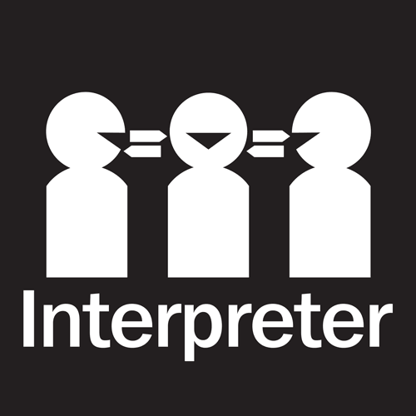
- Avoid situations which can trigger symptoms such as crowded or noisy environments and tasks which require multitasking. Symptoms can worsen under stressful conditions.
- If you are taking medication prescribed by your doctor, do not stop taking it unless advised to do so by a doctor. Your doctor may give you specific advice if you are on blood thinners or have a bleeding problem.
- Do not drink alcohol or take non-prescription drugs as this can slow the rate of recovery and may worsen symptoms.
- Do not spend too much screen time on mobile phone, computer or TV.
- Do not consume large amounts of food/drink containing lots of sugar or caffeine as these can worsen symptoms.
- It is recommended you do not play sports until all symptoms have settled. Playing sports can increase chances of sustaining another injury. Talk to your doctor about a gradual return to play.

Recovery & Follow Up
For most people, symptoms recover on their own within several days to a few weeks, and most people recover within three months. A minority of people experience persistent symptoms.See you local doctor wtihin 1-2 weeks of your concussion/mild TBI. If your symptoms are severe and/or are not settling, your local doctor may refer you to a Traumatic Brain Injury Specialist Service.
Central Adelaide Local Health Network
Consumer Information
Sheet

Concussion & Mild Traumatic Brain Injury:

Discharge Advice for Adults
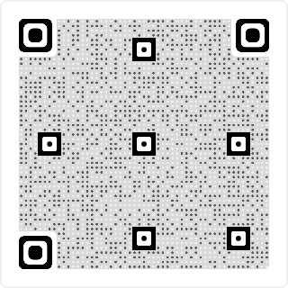‘Concussion & MTBI: A Guide To Support Recovery’

South Australian Brain Injury Rehabilitation Service

Version No. | Current at | Next Review
3.0 | 20.08.21 | 20.08.2022
© Department for Health and Wellbeing, Government of South Australia. All rights reserved.

