Health Protection Programs Resources Order Form
(June 2023)

Resource details |  |  |  | Office Use Only |  | Order limits |  |  | Quantity requested
Head lice resource

Head lice posters – A4 |  |  | 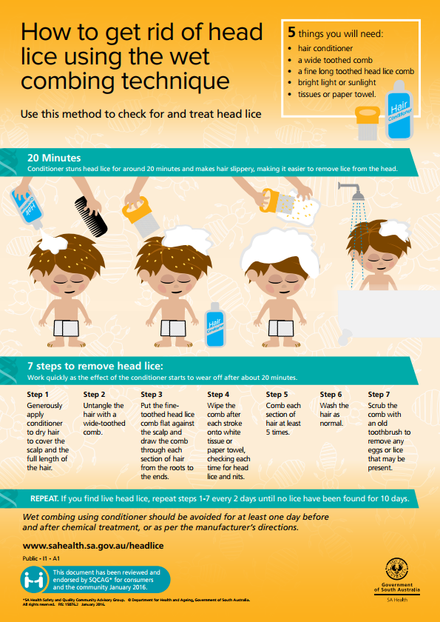 | (HPR011) |  | Maximum 20
Swimming pool resources

‘Keep the pool clean swimmers’  - poster – A4  - poster – A3  - corflute A3 |  |  | 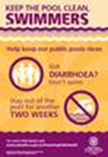 | (HPR020)  (HPR021)  (HPR022) |  | Maximum 50  Maximum 20  Maximum 50
‘Keep the pool clean swimmers’ infographic – A4 |  |  | 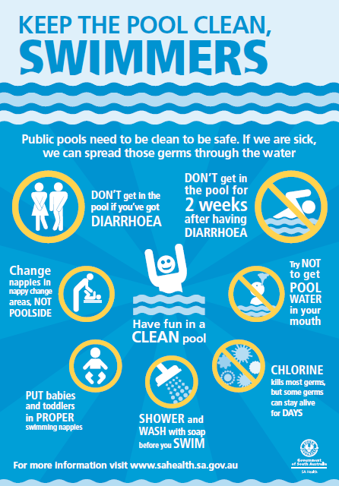 | (HPR023) |  | Maximum 10
Standard for the Operation of Swimming Pools and Spa Pools - A4 book |  |  | 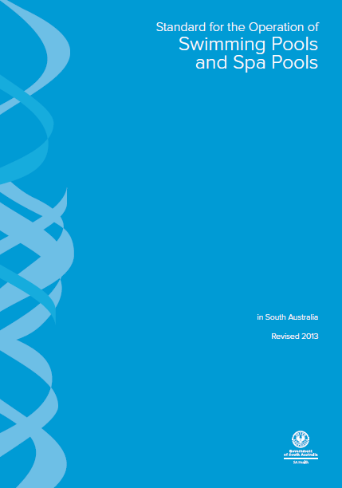 | (HPR024) |  | Maximum 5
Mosquito resources

Fight the bite poster – A4 | 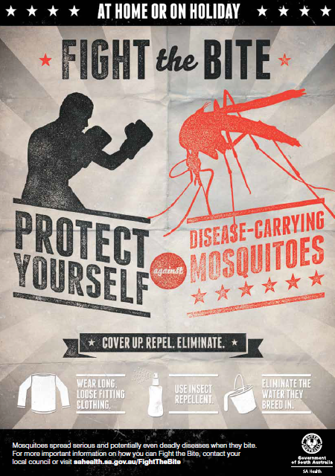 |  |  |  | (HPR032) |  |  | Maximum 25
Fight the bite brochure - DL | 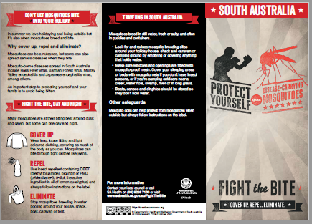 |  |  |  | (HPR033) |  |  | Maximum 100
‘Fight the bite  - poster – A4  - poster – A3  - corflute A3  - corflute A2 | 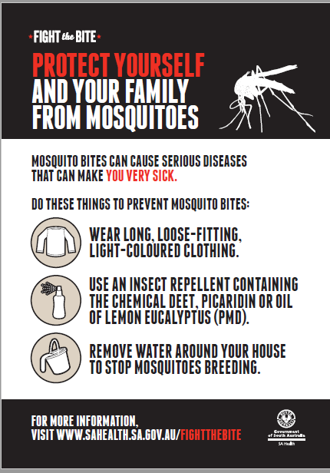 |  |  |  | (HPR034)  (HPR035)  (HPR036)  (HPR037) |  |  | Maximum 20  Maximum 20  Maximum 5  Maximum 2
Fight the bite stubby holder | 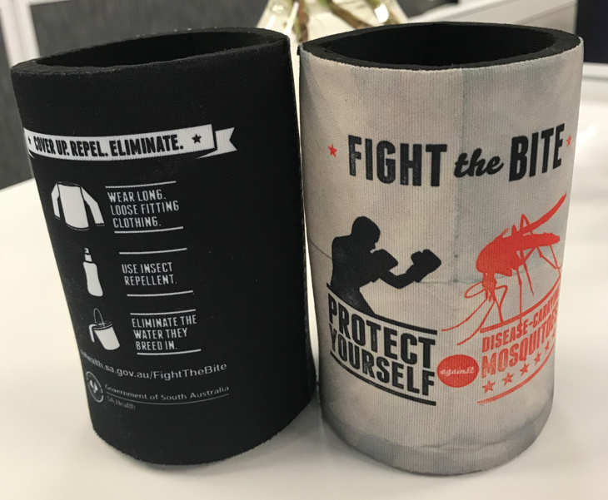 |  |  |  | (HPR038) |  |  | Maximum 10
Animal contact resources

Animal contact guidelines – A4 book | 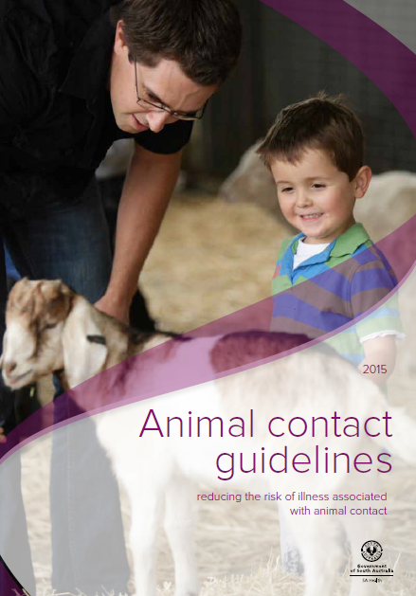 |  |  |  | (HPR050) |  |  | Maximum 5
Grey headed flying fox corflute sign 600mm x 900mm | 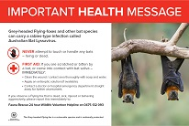 |  |  |  | (HPR051) |  |  | Maximum 4
Legionella resources

Guidelines for the control of Legionella – A4 book | 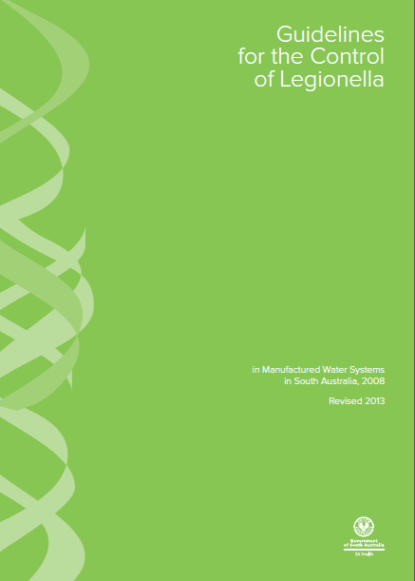 |  |  |  | (HPR040) |  |  | Maximum 5
enHealth Guidelines for Legionella Control – A4 book | 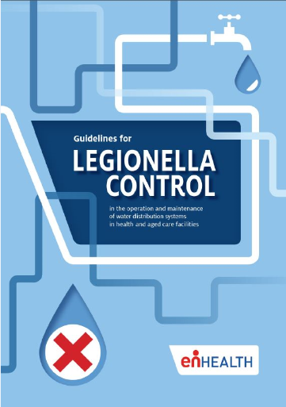 |  |  |  | (HPR041) |  |  | Maximum 5
Sharps disposal resources

Sharps disposal warning sign (sticker) A6 |  | 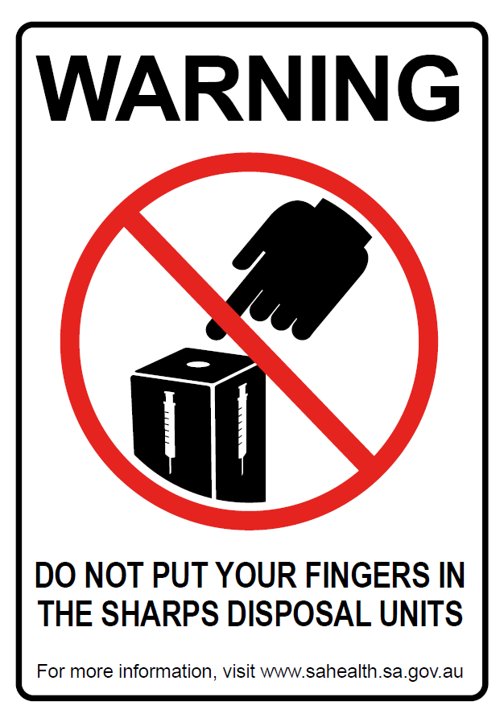 |  |  | (HPR060) |  | Maximum 100
Tattoo and body piercing resources

Stay sharp stay safe (red) A4 |  | 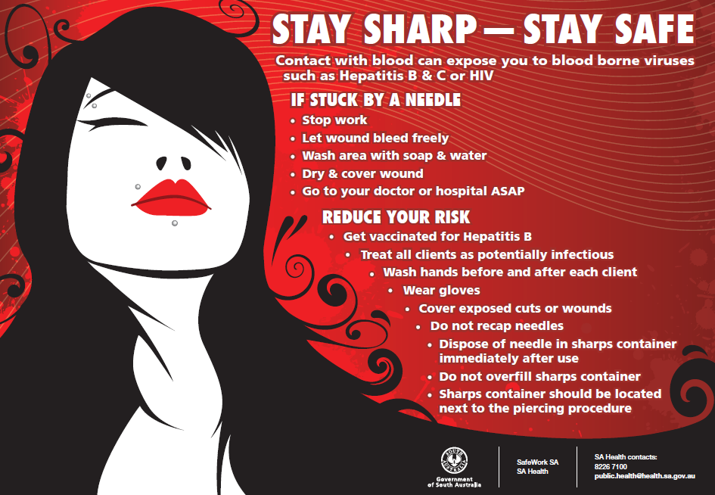 |  |  | (HPR070) |  | Maximum 5
Stay sharp stay safe (blue) A4 |  | 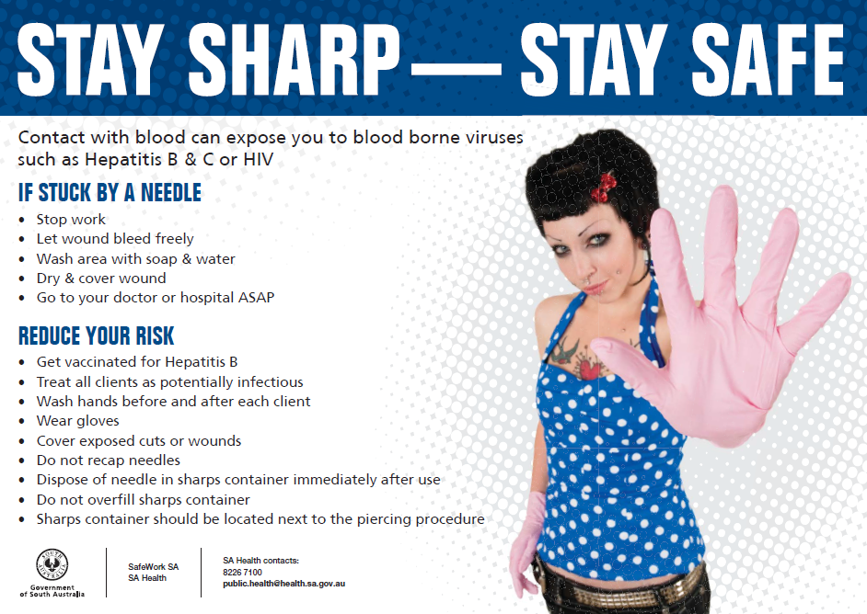 |  |  | (HPR071) |  | Maximum 5
Good clean body art (blue) A3 |  | 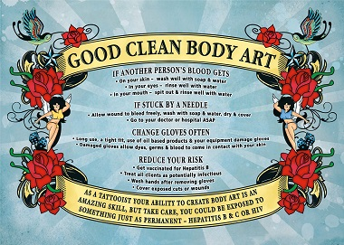 |  |  | (HPR072) |  | Maximum 5
Good clean body art (black) A3 |  | 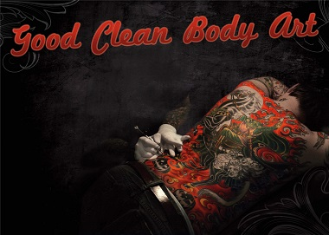 |  |  | (HPR073) |  | Maximum 5

Please Note:
- These resources are available FREE OF CHARGE.
- You will not receive confirmation of your order.
- No more than the maximum amount of resources outlined on the order form will be provided. If you require more than the listed maximum number, please contact Health Protection Programs on 8226 7100
- Due to the limited resources, your order may not be filled exactly as per your request.
- Resources are for distribution in South Australia only.

This section must be completed

Contact person | Position

Organisation name
Postal address | Suburb Postcode
e-mail address | Telephone

Please email the completed Resources Order Form to: healthprotectionprograms@sa.gov.au

If you have any queries please phone Health Protection Programs on: 08 8226 7100



