SA Health

New or Revised Cancer Chemotherapy Protocol Registration – Application Form
GENERAL INFORMATION
This form is to be used to apply to the SA Health Cancer Drug Committee for new or revised Cancer Chemotherapy protocols to be approved for use in SA Health Hospitals.
Completion of this form is intended to be undertaken with a multi-disciplinary, across Local Health Networks (LHN), collaborative approach.
SA Cancer Drug Committee Members or your cancer clinical pharmacist can provide advice and assistance in completing this form.
Consultation with cancer services in other LHN’s or similar expert groups is recommended to ensure a standard approach and agreement state-wide.
Failure to complete all details may result in a delay in consideration of the application by the SA Cancer Drug Committee, and therefore delay approval and addition of the protocol to the register.
Note: For approval to use a non-registered Cancer Chemotherapy Protocol for Individual Patient, please use the Use of a Non-Registered Cancer Chemotherapy Protocol Request Form.
PROCESS FOR APPLICATION
- All applications to be completed by a Consultant Oncologist/Haematologist or appropriate consultant specialist
- The signature of the relevant tumour stream lead or equivalent must be obtained to indicate endorsement of the application
- The signed, completed forms should be forwarded to the SA Health Cancer drug Committee Project Pharmacist at SAHealthCancerDrugCommittee.GenericMailbox@sa.gov.au
- Protocols being used as part of a clinical trial that has been approved by the appropriate Ethics Committee and Drug and Therapeutic Committees do not require approval by this process. The SA Health Cancer Drug Committee Project Pharmacist must be notified of chemotherapy protocols being used in clinical trials for the purposes of maintaining the SA Health Cancer Chemotherapy Protocol Register

For new protocols only:
- If the protocol includes any medicines that are not on the South Australian Medicines Formulary, or are not listed on the Formulary for the particular indication for this protocol, a separate formulary application will need to be made for those medicines.
- If the protocol includes any high cost medicines, a separate application to the South Australian Medicines Evaluation Panel (SAMEP) is required

- APPLICATION
  - Application Details
Name of Protocol:
Select Reason for Request:
New Cancer Chemotherapy Protocol Required
Revision to existing Cancer Chemotherapy Protocol Required
Type of Application:
eviQ protocol to be added to SA Health Approved Protocol Register
Other published protocol from a Co-operative Trials Group or other approved source
New protocol (evidence to be submitted with this form)
Date of Application:
Sponsoring Clinician:

  - Details of Protocol
If the protocol is endorsed by eviQ, please attach a copy of the eviQ Cancer Treatment Protocol
If the protocol is not endorsed by eviQ, please complete Protocol Template (eviQ format) supplied by the SA Health Cancer Drug Committee
If protocol is a deviation from a standard eviQ protocol – please attach eviQ Cancer Treatment Protocol and enter data on relevant fields in the protocol template (eviQ format) to ensure that all information on the variation and evidence supporting that variation are available to the committee.
  - Registration Status

Are all the medicines included in the protocol registered by the TGA? Yes No
Are all the medicines included in the protocol registered by the TGA for the requested indication?
Yes No

  - Rationale for inclusion of this protocol on the SA Health Approved Cancer Chemotherapy Protocol Register

Reasons for requesting this protocol:

  - Comparators or current therapies available

Protocols currently used for the requested indication(s):

Protocols currently listed on the SA Health Approved Cancer Chemotherapy Protocol Register that could be deleted from the register if this request is approved (if applicable):

  - Clinical Pathway

Provide details of the proposed clinical pathway or place in therapy of the requested medicine (i.e. first, second line etc) that includes the new protocol for the indication requested:

  - Treatment aims

What is/are the treatment aims with this protocol? (e.g. curative, adjuvant, palliative?)

Suggest practical ways in which the overall treatment outcomes can be measured and monitored:

Are there significant safety concerns that should be considered or monitored for? Yes No
If Yes, provide details including any objective criteria that will be used for monitoring

  - Evidence to support use of this chemotherapy for the proposed indication

Best available evidence*
Provide details of key studies relevant to this submission including evidence for use in proposed treatment population:

Other references*
Provide details of other studies which may be relevant to this submission i.e. unpublished clinical trials and conference proceedings:

Assessment of Evidence
Provide summation of evidence quality and quantity based on NHMRC Evidence Hierarchy (see Appendix I)

*Include electronic copy of full text or printed copy if not available electronically

  - Proposed Treatment Risk Level for Chemotherapy Unit Administration (SA Cancer Standards 2010)

Level 1-3 (Low)
Level 4-5 (Medium)
Level 6 (High)

  - Input from others – tumour stream groups and stakeholder consultation

Provide details of the extent of consultation and consensus amongst relevant clinical colleagues in support of this application including tumour stream groups and clinical networks:

(Note: for High cost medicines the opinion of South Australian Cancer Service (tbc) must be sought prior to submission)

  - Input from others - Pharmaceutical Industry

Was a pharmaceutical company involved in the preparation of this submission? Yes No
If yes, provide a brief description of the nature of involvement or assistance:

- AUTHORISATION

  - Applicant Details

Consultant Name:
Position:
Clinical Unit, Hospital/LHN:
Telephone: Pager:
Mobile: Email:
Conflict of Interest:
Financial or other resulting from contact with pharmaceutical companies, which have a bearing on this submission.
Yes No
If yes tick relevant box:
Gifts Travel Expenses Conference Funding Samples
Industry paid food/refreshments Research Support Honoraria
Other support (describe)
Please provide a brief but clear description of each potential conflict:

I declare, that to the best of my knowledge, all the information contained in this application is true and accurate:

Consultant Name:
Telephone: Pager:
Email:

Signature:__________________________ Date:

  - Authorisation by Tumour Stream Lead* (* full new protocols only)

Consultant Name:
Position:
Clinical Unit, Hospital/LHN:
Telephone: Pager:
Mobile: Email:
Signature:__________________________ Date:

  - Authorisation by Specialist Pharmacist

Name:
Position:
Clinical Unit, Hospital/LHN:
Telephone: Pager:
Mobile: Email:
Signature:__________________________ Date:

  - Authorisation by Specialist Nurse

Name:
Position:
Clinical Unit, Hospital/LHN:
Telephone: Pager:
Mobile: Email:
Signature:__________________________ Date:

  - Authorisation by SA Health Cancer Drug Committee Chair (or delegate)

SAH-CDC use only
Application received (date):
Confirmation of costing confirmed*
Approval Status
APPROVED
Conditions of approval (if any):
REJECTED
Reason(s) for rejection:
Treatment Risk Level allocated:
SAH-CDC comments (if any)

I acknowledge the application and to the best of my knowledge the information contained within is correct and confirm the decision made by the SA Health Cancer drug Committee in submitting this protocol to the SA Health Approved Cancer Chemotherapy Protocol Register:

SAH-CDC Chair (or delegate): Position:
Signature: Date:

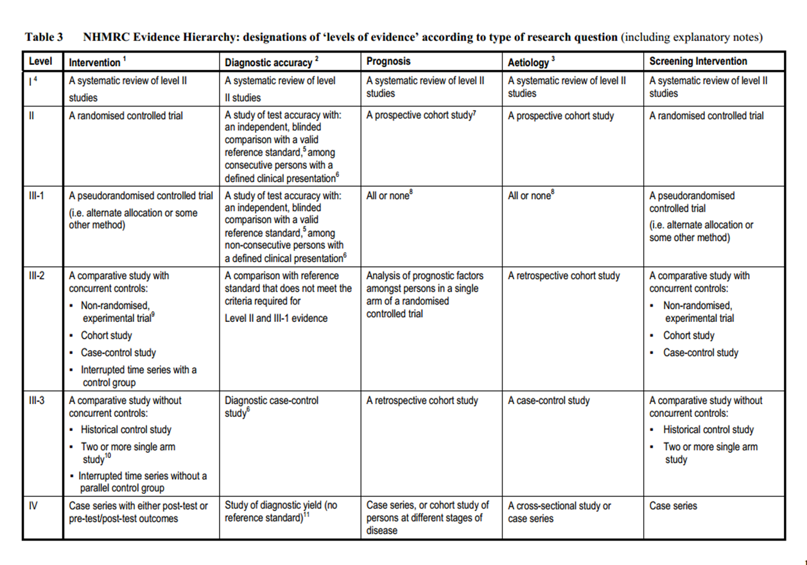
Appendix I - NHMRC Evidence Hierarchy (for full information and references please access NHMRC website)
NHMRC additional levels of evidence and grades for recommendations for developers of guidelines (accessed online May 2017)

